Instructions for Recording your Presentation for the
IEEE Aerospace Conference Electronic Presentation Hall
Prerequisites:
- Zoom App installed & updated to latest version
- If you are using a work computer and not able to install the app, try using the web app instead.
- MacOS: allow Zoom to record your screen (enable in System Preferences >> security & privacy)
- Computer with working microphone (camera strongly encouraged)
- Preferred internet browser: Chrome
- Recording on a personal computer is recommended to avoid firewalls and other restrictions.

- Launch Zoom and sign in to your Zoom account (you can create an account for free if you don’t already have one).
- On the Aerospace Conference website, go to “My Submissions” (see right, or use this direct link). | 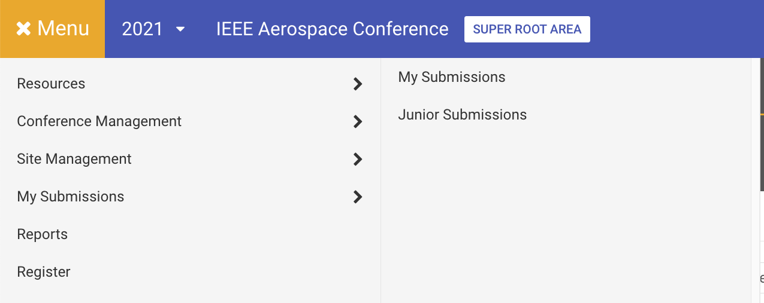
- Ensure that you have selected Electronic Presentation Hall (EPH) for Presentation Details. If you have already done this, you may skip this step.  Look for the paper that you want to present as EPH and scroll to the bottom of the screen. Look for the Presentation details button. If you have not yet submitted Presentation Details, the button will be labeled “No Presentation Details Submitted” and will be yellow. If you have already submitted Presentation Details, it will be labeled “Change Presentation Details” and will be green (and you may skip this step). Click on this button and select EPH, provide a brief presentation summary, then click on the “Save” button.  Note: Only the paper’s first author may click on this and select Presentation Details. | 
- Look for the paper for which you want to record a video presentation, and scroll to the bottom of screen. On the left hand side, click the “Add your Video Presentation” button to enter the presentation recording area. | 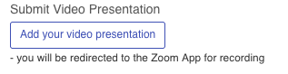
- To add a new recording, click the “Add new video presentation” button. This will launch the Zoom app (but will not begin recording yet). | 
- You may need to give your browser permission to launch Zoom. | 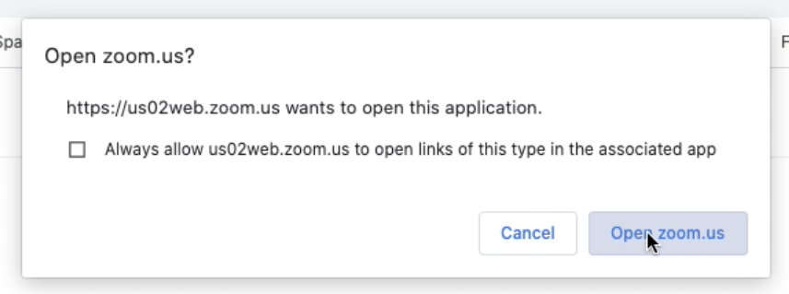
- You will be placed into a special zoom meeting (you are the only attendee). Here you will present and record your talk. Please select “Join with Computer Audio.” If you have an external headset or microphone, you will see options for those and can use those if desired.  Note: EPH talks, like in-person talks, are limited to 20 minutes. The Zoom session will last 35 minutes to give you some time to prepare. | 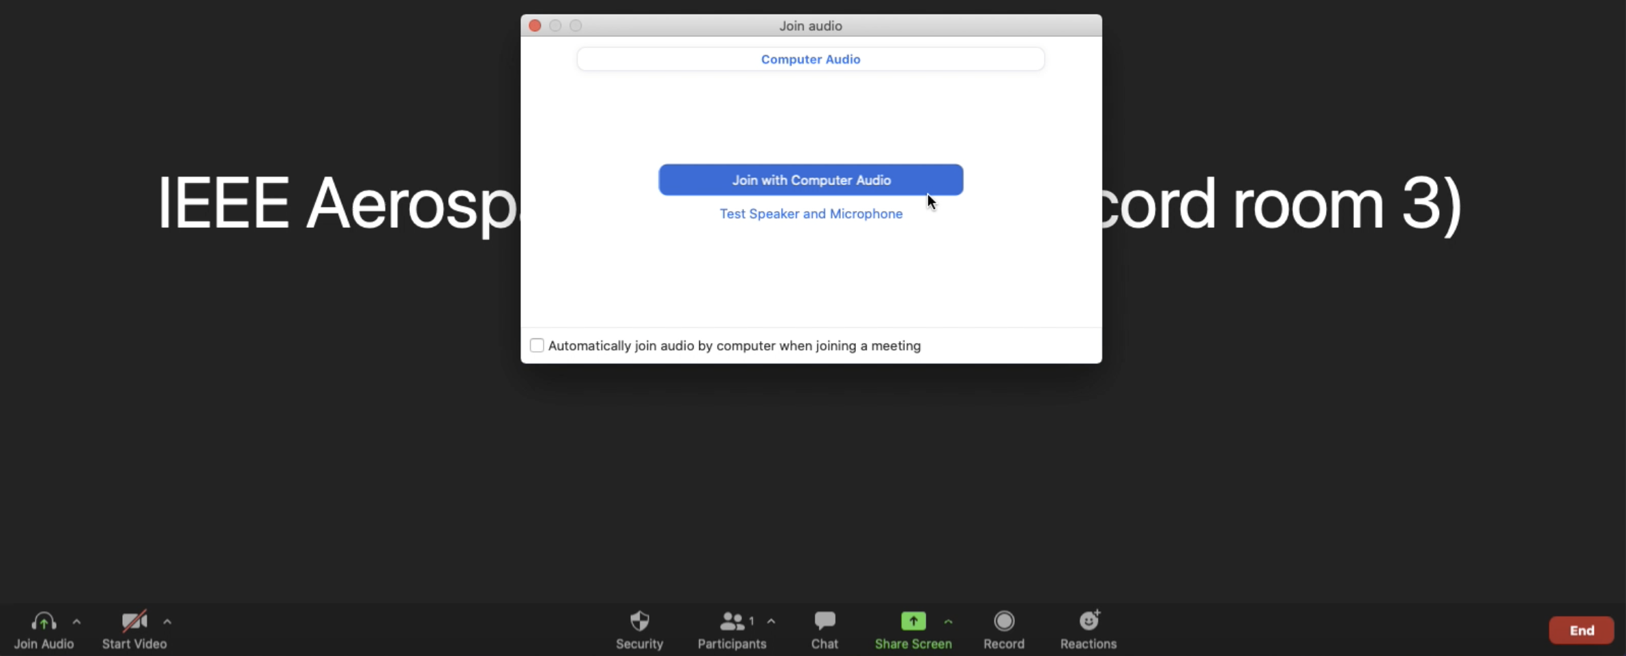
- Turn on the microphone and camera (when you have done this, the icons will look like the “CORRECT” image at right).  Note: hit the up-arrows next to the microphone and video icons to select which audio and video inputs Zoom is using or confirm that the correct inputs are selected | 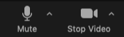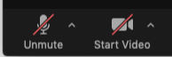  CORRECT INCORRECT
- Click the “Share Screen” button at the bottom of the Zoom window | 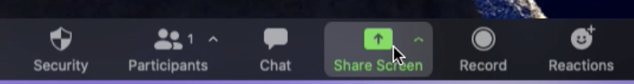
- You will be prompted to select which screen or application to share. Select Power Point (or whichever application that you used to make your presentation), and then click “Share” at the bottom-right of the window. | 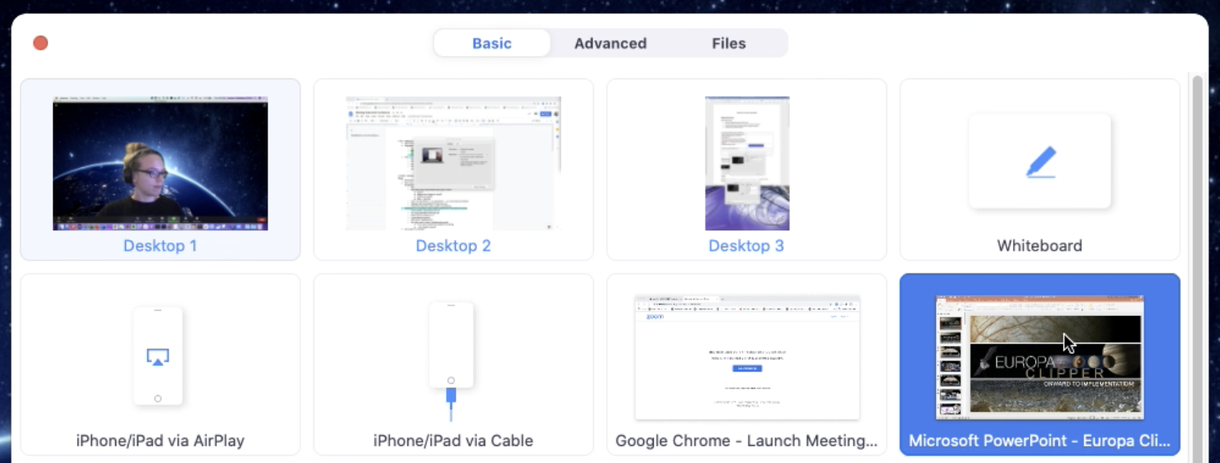
- You will now see your computer screen. Your presentation, which is being shared, is surrounded by a green border. You will see your video in the upper right, and the zoom controls at the top of your screen. You are not recording yet. | 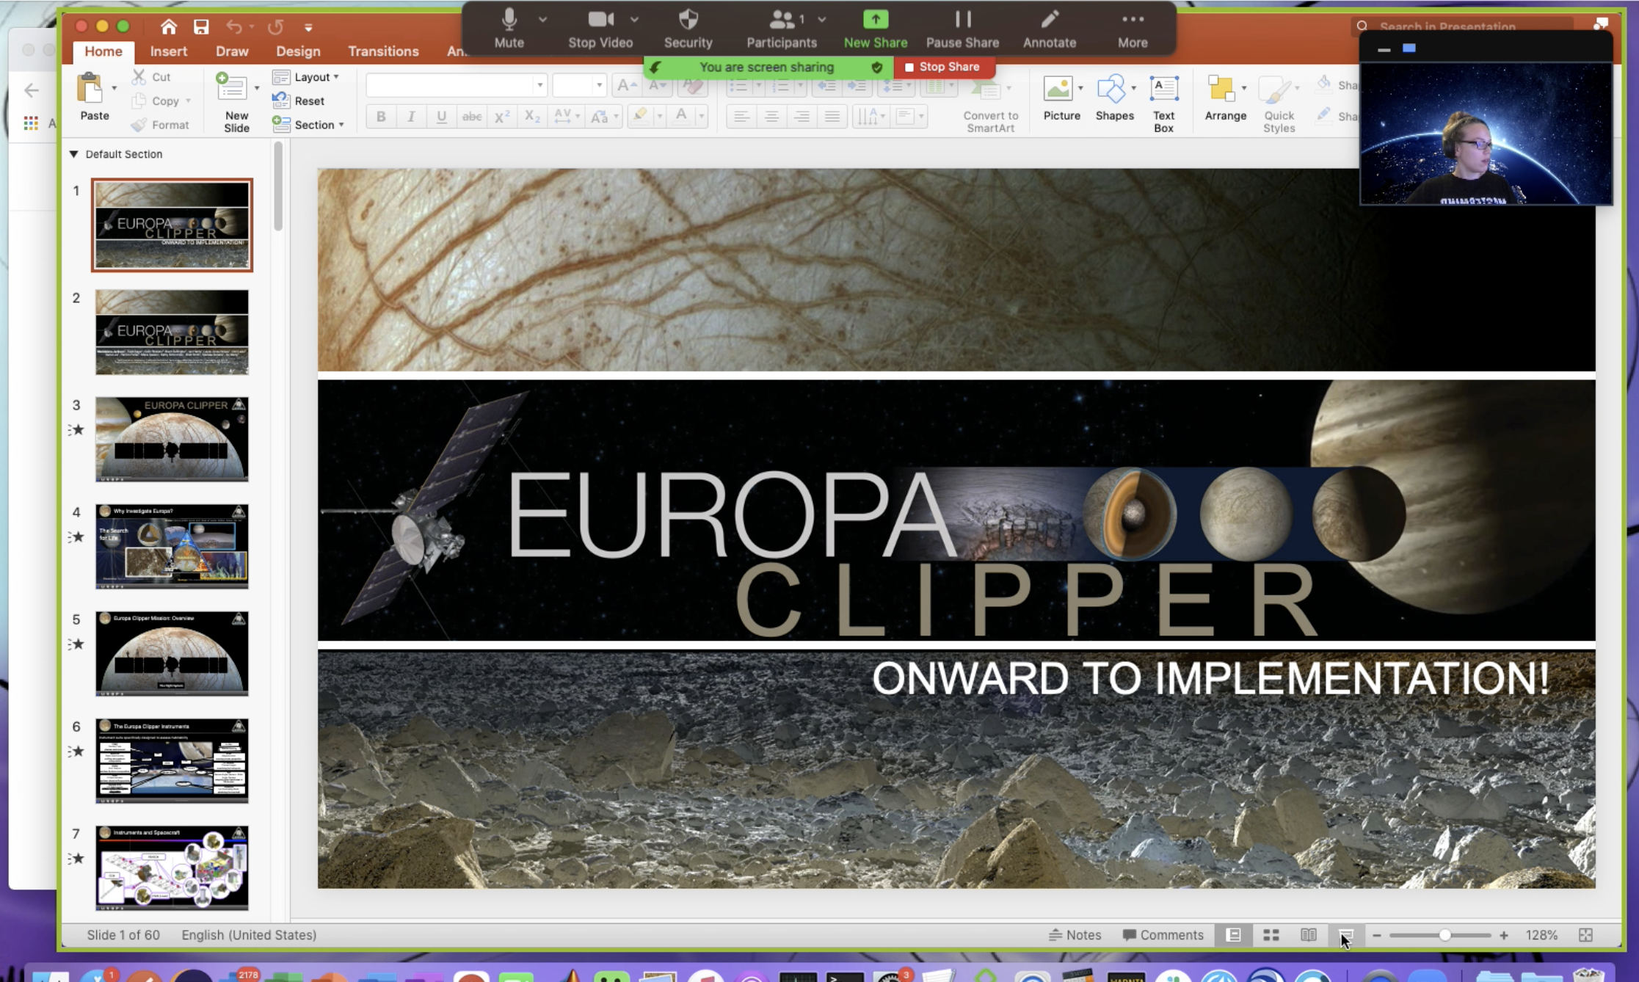
- Hit the Slide Show button in Power Point to enter into Presenter Mode.  If you have more than one screen, please make sure that Zoom is not recording the “presenter view” mode (which shows upcoming slides and notes). The screen you are recording is the screen with the Zoom controls. | 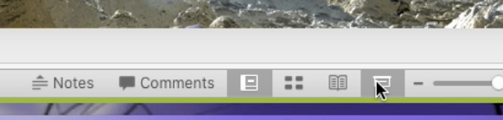
- When you are ready to start recording your talk, select “More” from the Zoom menu at the top of the screen, and then “Record to the Cloud”  This will begin the recording, so please be ready!  Make sure you do this step or your recording will be empty! | 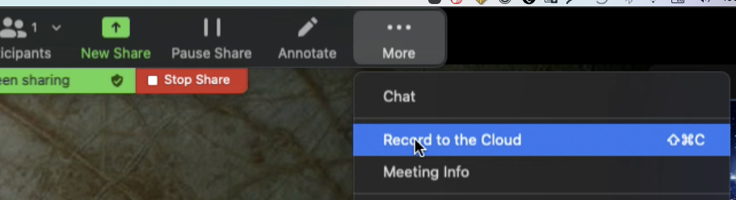
- While your Session Organizer is not with you to give you a time check, you will be limited to a 20 minute presentation, and you don’t want to get cut off before you are done! Please prepare in advance so that you can give your talk in 20 minutes. | Record your talk  20 minute limit
- When you are finished, move your mouse to the top of the screen to make the Zoom controls visible. Then, hit “More” and then “Stop Recording.”  When prompted, confirm by clicking “Stop Recording.”  (This step will not be recorded by Zoom in the final video.) | 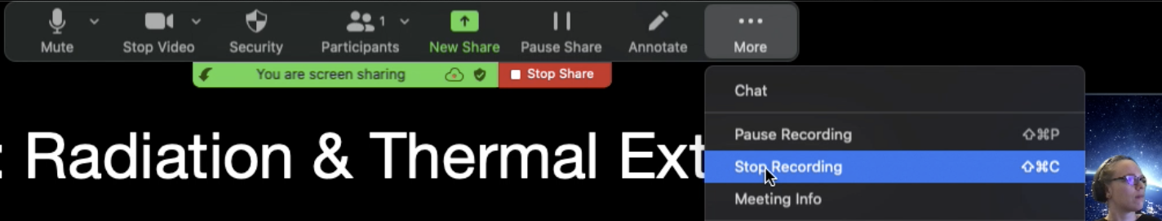  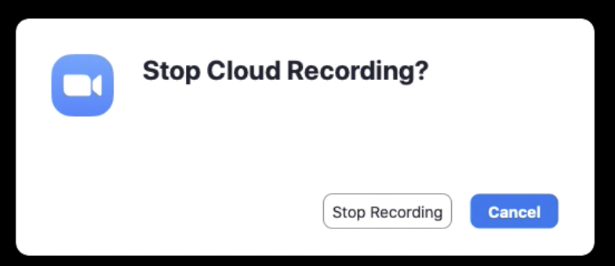
- You may now end your screen share | 
- When you are back to the standard zoom room, you may hit the “End” button and then “End Meeting for All” at the lower right to close the Zoom meeting and post the video to the Aerospace Conference website. | 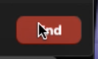  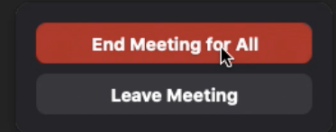
- Back on the conference website, you will see an entry for the presentation you just recorded.  Wait a few minutes, then refresh the page until you see your video posted. | 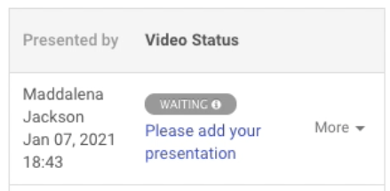
When your video has posted, it will look like this. Please play your video back to confirm that  - Screen recording, audio, and video were captured successfully  - Your entire presentation was captured  - You are satisfied with your recording | 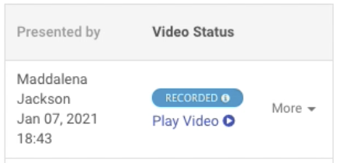
You may save up to 5 videos at one time. When you have a version of your presentation that you are happy with, click “Send to Review” to submit that version for review. | 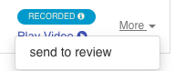

Tips and Tricks
- Record a very short test video to practice the steps and confirm that your audio, video, and screen recording are working correctly.
- You may make as many attempts as you wish, although after 5 videos you will need to delete your previous attempts.
- Practice the timing of your talk in advance to ensure that you do not go over the 20 minute recording!
- MacOS: if you have not used Zoom’s screen share feature before, you will need to enable it in System Preferences >> Security & Privacy >> Privacy tab (allow Zoom to use your microphone, camera, and record screen).
  - Zoom will prompt you to update this setting and take you directly to the correct menus within System Preferences, but it will not take effect until you restart Zoom, which will require you to restart the recording process.
  - This is one of the reasons we recommend recording a test video or two!
Troubleshooting
- If your zoom sign-in is completely blank, uninstall and reinstall Zoom (Zoom can be uninstalled from the Zoom.us menu at the top of the screen)

