Thank you for volunteering to review technical papers online. We need and appreciate your help. We have 431 papers, and we strive to attain three separate reviews on each paper. Please ensure your reviews are completed by November 2, 2025.
Note that our reviewers are anonymous, and all scores and recommendations are inaccessible to anyone outside the review committee.
Establishing a Reviewer Account. If you do NOT already have a reviewer account, please Login to the website www.aeroconf.org/volunteer. Select the tracks and sessions of interest, then enter a few words about your areas of expertise, click the Online Review volunteer box, then SAVE.
Selecting a Paper to Review. When you're ready to review papers, Login, open the Orange Menu at the top-left of the web page, click Conference Management, dropdown, select Review Submissions. As shown in the screenshot below, there are 7 columns; each is sortable. In the search box you may search by track, session, paper title, or user last name, first name, or email (min. 3 chars). Using the filter icon, you can filter by track, session, or author. Download a paper of interest by clicking the download link under the paper title (solid red circle below). You will be asked if you intend to review the paper before the download is enabled.
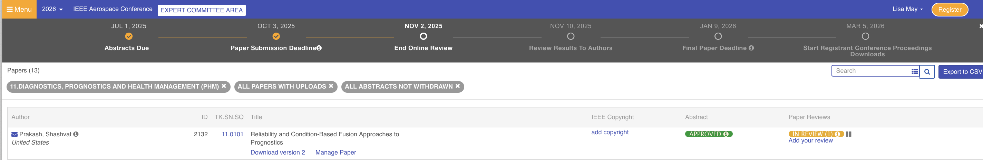
Reviewing a Paper
Please read the downloaded paper thoroughly. You are welcome to print it or work with a digital copy, but you may not share the version you download. Only final published papers can be shared outside the review process.
You may find it useful to download the Author's Instructions under Resources on the website to compare the review paper's format against the conference standard. When you are ready to enter comments online, click on "Add your review" (see arrow above) to bring up the Technical Review form. See screenshot of Technical Review form below.
On the right side of the Technical Review form, in the General Comments box, enter your summary comments and any specific comments you want to share. Note that the review should be for the paper that was submitted, not one you might prefer the authors had written. Focus comments on constructive actions the authors can/should take for their final papers if accepted. While formatting issues need to be called out, disregard small spacing discrepancies in your formatting reviews. If you feel the paper would benefit from a conference committee language review for overall grammar and usage, check the box in the lower right rather than doing extensive editing yourself.
If you find issues that must be corrected for the paper to be published, enter those in the Critical Comments box. A Critical Comment will automatically cause the paper to be placed on hold and tracked to publication until released by the Session Chair for that session. This includes incorrect formats and missing copyright footer. The correct copyright footer for 2026 is “979-8-3315-7360-7/26/$31.00 ©2026 IEEE”. Anything other than that—or if it is missing altogether—should be noted in the Critical Comments. Do not use Critical Comments for things you would like to see improved. It is meant only for things that would prevent publication.
Only the comments in these boxes go to the author; nothing else does. If you have markups to the paper that would help the authors, you can upload the marked up version as a PDF to the website (see instructions below). Use the Critical Comments field carefully and only for issues that must be corrected for publication of the paper. Avoid pejorative comments. Make your comments professional and constructive. Remember, it is our goal to help the author improve the paper.
Scoring the Paper
To add your review and score the paper, click on Add your review (dashed blue circle above). Before scoring the paper, please indicate your expertise in the subject matter. Under Reviewer Self Evaluation at the top left of the Technical Review form, choose the number that best describes your combined subject expertise using the following guidance:
- ﻿﻿﻿Novice: Have no expertise; understood enough to know if the paper is well-written
- ﻿﻿﻿Novice/Generalist: Have some knowledge in the general area; understood and evaluated much of the paper
- ﻿﻿﻿Generalist: Have general expertise in the broad area; specific topic may be new and mostly understood - OR - have expertise in this area but did a cursory review
- ﻿﻿﻿Generalist/Expert: Have sufficient knowledge in this technical area to understand the topic and follow the author's logic
- ﻿﻿﻿Subject Matter Expert: Have technical expertise in this area, am knowledgeable in the current state of the art, and assessed the author's conclusions
Score the paper by checking the box that most closely represents your opinion of the paper's Technical Strength, Novelty, Relevance, and Presentation Quality and then make a recommendation on its acceptance. Scores are not published. They are used solely to rank the papers and to find any that are too weak to go forward—usually, about 12 to 15% of the papers submitted. The scoring process is well-validated and strongly correlates to the best paper nominations and papers recommended to be rejected by the reviewers.
If you think the paper is exceptionally good, check the box under Other Opinions to nominate it for a Best Paper Award. Check the box for Language Review (on the lower right but not in the screenshot below) if you feel that would help the paper.
Attaching Scanned Comments and SAVING Your Review
To send the author an annotated paper you have scanned, use the Choose File button on the bottom left of the form. Remember to click the SAVE button (see red arrow). If you experience a problem on our website, please contact one of our web team members: WebGuru@aeroconf.org, paperreviewchair@aeroconf.org, conferencemanager@aeroconf.org

